|  |
| --- |
| inf_int class |

- Object Oriented Programming -



|  |  |
| --- | --- |
| 팀 장 | 20206434 염경하 |
| 발표자 | 20214466 정재일 |
| 팀 원 | 20215725 고하영 |
| 팀 원 | 20202850 김지민 |
| 팀 원 | 20212571 이지수 |
| 팀 원 | 20201776 허 인 |

**1. Specification of the Project Problem**

The goal of this project is implementing inf_int class that represents infinite precision integer and its operations. The calculator we use in the real world, cannot derives the result and stop working when the input number is too large (when input number is infinite precision integer). The project aims to overcome the limits of calculator.

**II. Design about Program Structure and Module Specification**

The program for the project consists of 3 files, main.cpp, inf_int.cpp and inf_int.h. The program was designed using c++. The file main.cpp is for implementing various test cases, and to check whether the code generates correct result that we desire. The file inf_int.cpp specifies the implementation of the class inf_inf that is shown in inf_int.h. The entire program used dynamic memory allocation(new) and deallocation(delete) for handling variables sizes of infinite precision integer numbers. Now, let’s take a look at the class inf_int. Class inf_int consists of private and public members.

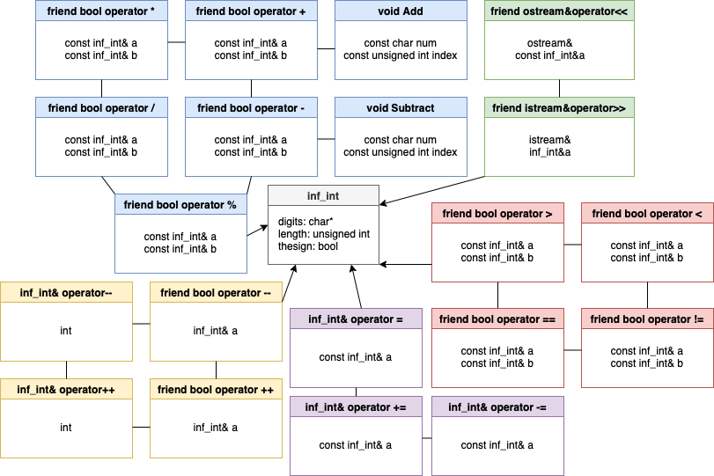

The diagram shown the above is the entire SW system. To make the class inf_int, there are several private and public members. Private members are included in the grey one. Public members are colored in various colors. They all just works for operation, but the same color goes for similar work. Blue operators do the basic operator, adding, subtracting, multiplying and dividing. Yellow works for postfix and prefix operator, red one works for comparing two values, which usually stands for bool. And the green one concerns with the input and output of the entire program.

**1. private member of class inf_int**

Private members of the class inf_int are shown below. They are char* digits, unsigned int length, bool the sign, void Add(const char, const unsigned int) and void Subtract(const char, const unsigned int).

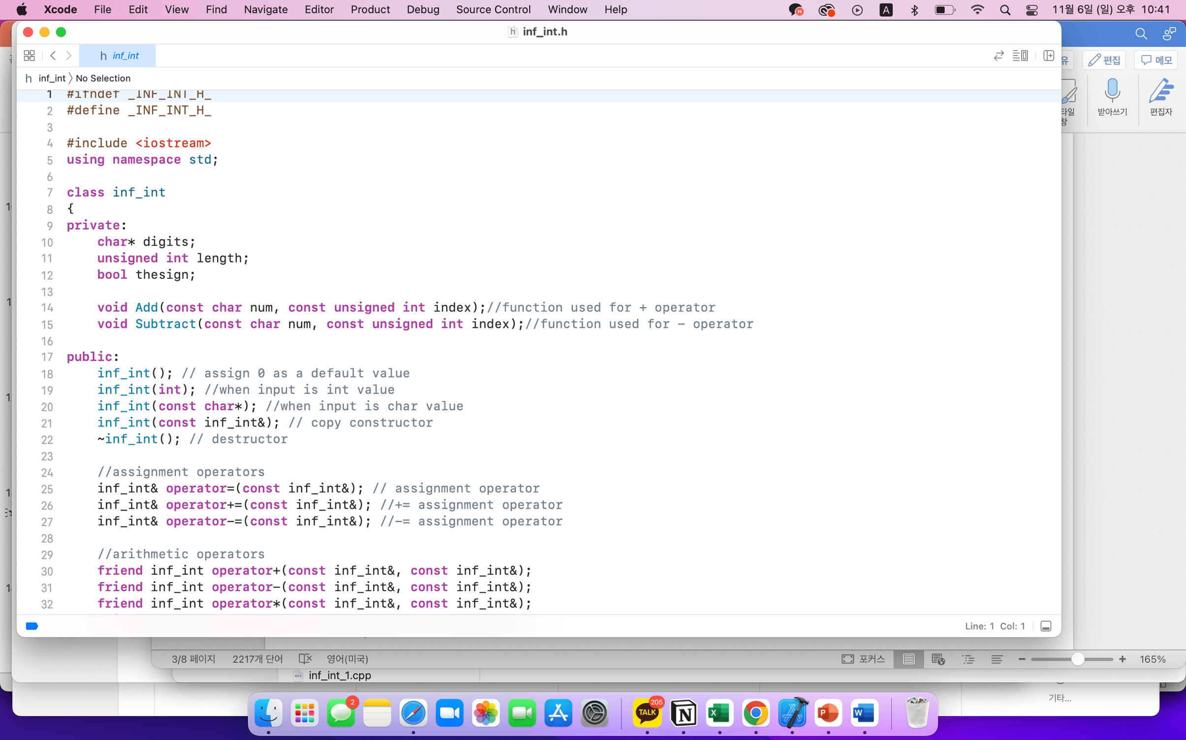

Char* digits plays a role for saving the input number as the form of ‘character’ not the ‘integer’ without any sign. And for the convenience of the programming, digits would save the input number in the reverse order. Let’s take an example. If the user makes an input number of -123456789987654, digits would save ‘456789987654321’ as ‘character’ type. The information of the sign of the input number would be saved separately, as the form of bool(bool thesign). If the sign of the input number is plus, then it would indicate true, otherwise the false. In the case of number that is mentioned above, -123456789987654, bool thesign would indicate ‘false’.

As the name shows, unsigned int length represents the length of the input number without the sign. The number -12345678987654 would have length=15. To sum up, the number would have information, digits=456789987654321, length=15, sign=false.

Two functions, void Add(const char, const unsigned int) and Subtract would be used for adding and subtracting operations. These functions are related to the public member, which will be introduced on the next page.

**2. Public member of class inf_int**

Public members of class inf_int are shown below. This paper would skip explaining details of the code provided by the professor. The paper would deal with the details of the code that our team produced. The details of the code is shown in inf_int.cpp.

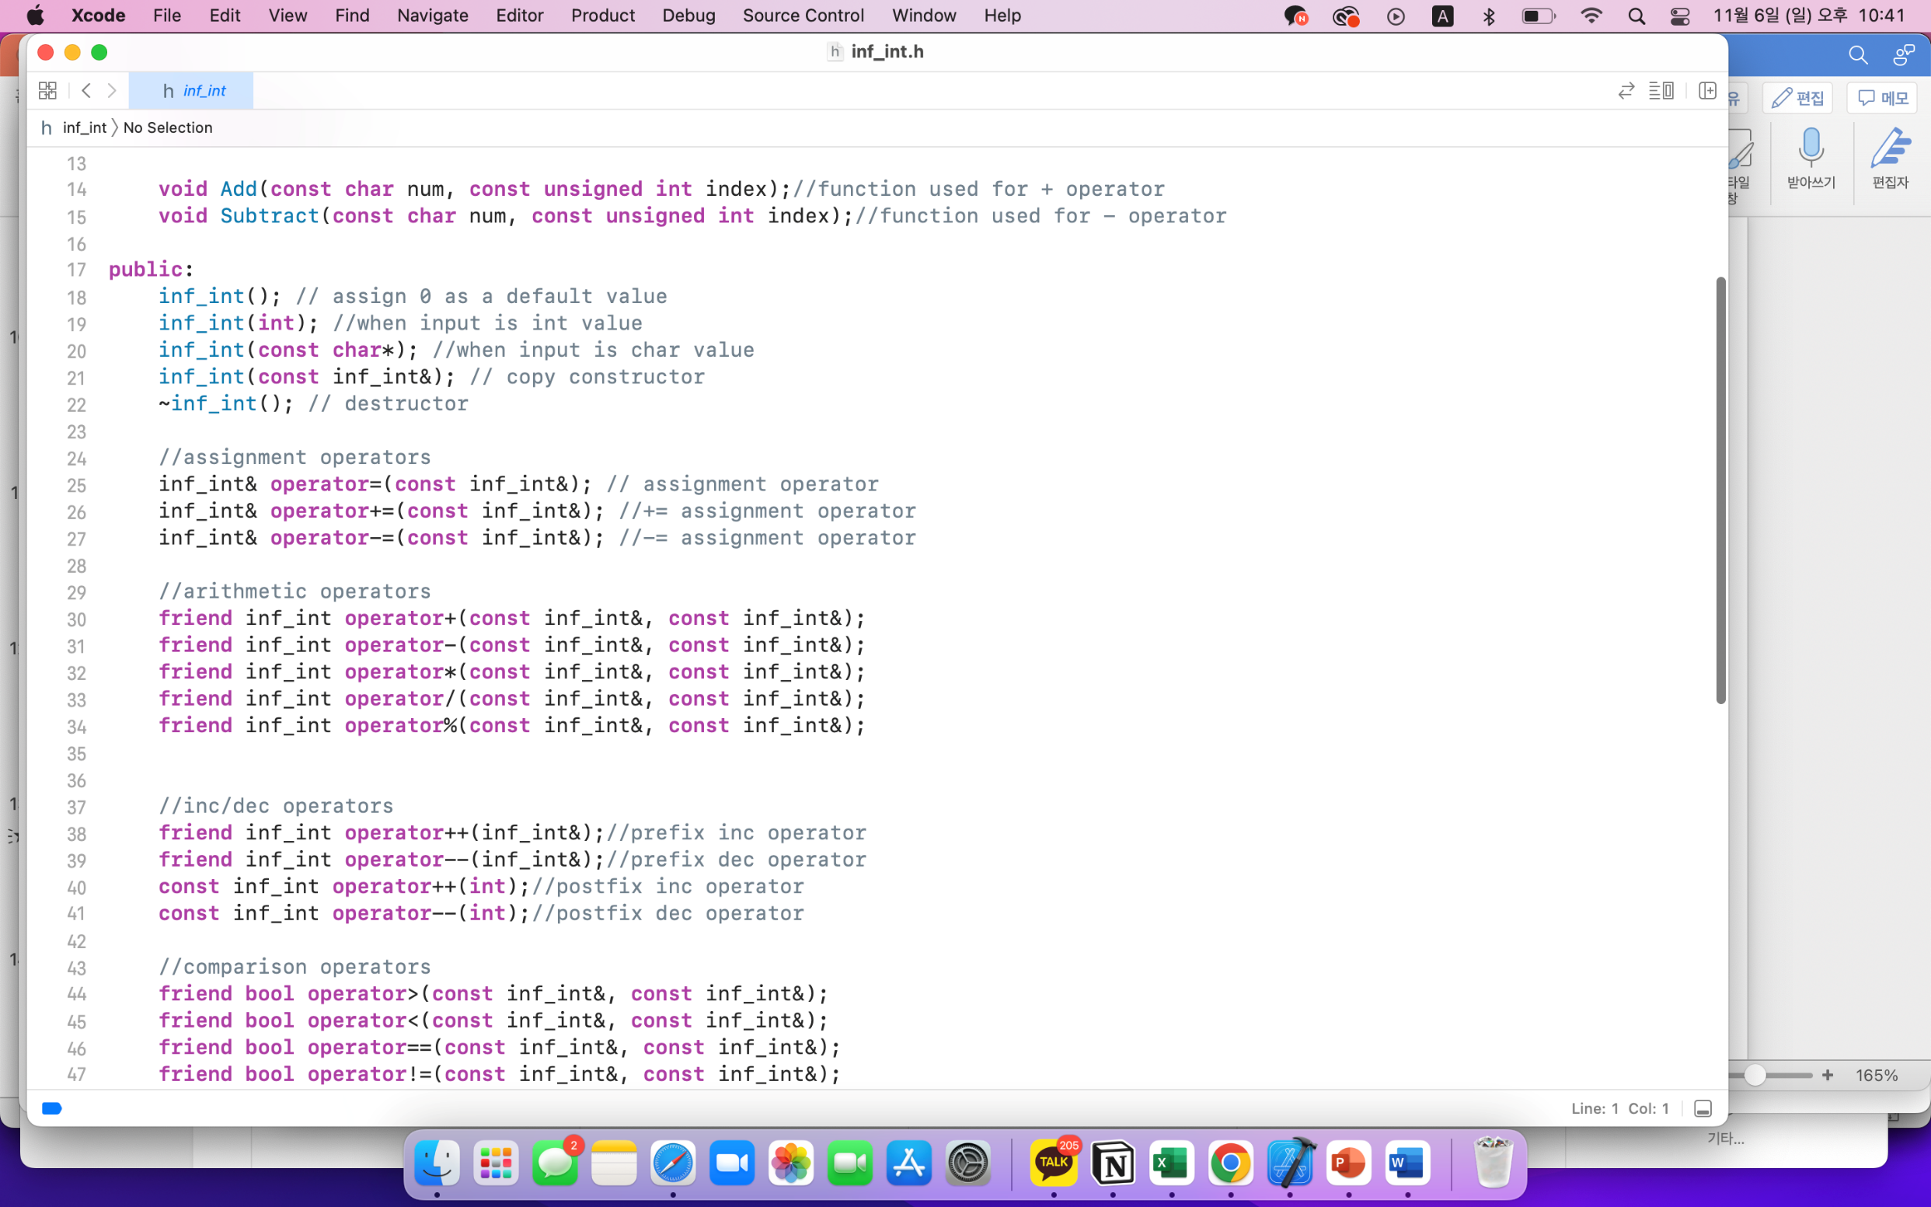

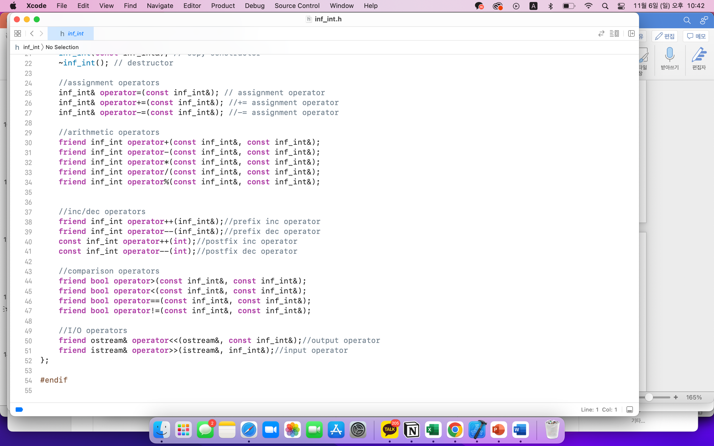

**(1) Basic member**

The member inf_int() indicates that we assign zero as a default value. Inf_int(int) works for converting integers to characters and deals with the sign of its input number. inf_int(const char* str) works quite similary with the above one, inf_int(int). However, inf_int(int) takes the input value as the form or integer, while inf_int(const char* str) takes the input value as the form of ‘character’.

Inf_int(const char* str) works with 3 cases. When the string has the form of number zero, positive number, or negative number. If input number is the form of number zero, the first letter of the input value would be zero, so it just returns inf_int() which has 0, a default value. To check whether the string is the form of positive or negative number, we should also take a look at the first letter of the value. If the first letter of the value is minus, then it means the input value takes a form of negative number, otherwise it’s positive number(As positive number usually doesn’t take a sign at the head, like 12345, instead of +12345). After dealing with the sign of the input string, then we save the input value without the bool at the variable digits, in the reverse order that we’ve mentioned above. To explain again, if the input value is -12345, then digits would be 54321. And it also stores the information of the length of the value without the bool, which is length = 5 in the case of -12345.

Inf_int(const inf_int&) is just a copy constructor and ~inf_int() is a destructor. Inf_int& operator=(const inf_int&) is an assignment operator, which just assigns value like a=3 that we simply use. As it is assigning the value, it delete the information if it had before.

**(2) bool operator**

This part looks at the bool operator, whether two input values are same, different, big or small. Friend operator==(const inf_int&, const inf_int&) checks whether two values are same. Using strcmp, we first check whether the digits of two values are same and the sign is same. If these two conditions are satisfied, then we return ‘true’ which means two values are same, otherwise the false. Bool operator!= just returns the opposite result of the operator==.

Bool operator> first checks the lengh of the input value. Regardless of the sign of both input values, if the one at the left side of the operator is longer, we get the result true, otherwise the false. But this step didn’t consider the sign yet, so it is not the final result value. If the length of the both values are same, when we should compare digits of both values using strcmp and derive the result. After these steps, if the sign of both values are plus, then it returns the result itself that was derived. But, if the sign of values are both minus, that it returns the opposite of the result that we’ve derived. If the sign of values are different, like one is plus, and the other is minus, then we just return the result related to the sign of the value at the left side of the operator. Bool operator< is correlated with the operator> and operator==. If the case is either operator> or operator==, it returns false, otherwise true.

**(3) Arithmetic Operation operator – 1**

This part deals with the basic arithmetic operation just like +, -, *, /, %. As the name shows, operator+ is to add two values. If the sign of two values are same, then we do the operation using ‘Add’ that is going to mentioned below. If the sign is different, then ‘Subtract’ would be used for operation. ‘Add’ operation just works like we do adding by hand. First of all, just add two numbers, and if there’s a case of rounding up, which means if the sum of two values are more than 9, when we subtract the 10 from the current digit index and add the number 1 on the upper index. ‘Subtract’ also works very similarly. If the difference between two values(subtract of two values) is smaller then zero, then we add 10 to the current index and subtract 1 at the next index of the digits. Using this principle, operator- does work. If the sign of the both values are same, then we first add number at the left side of the operator- to the zero value, and then subtract the value at the right side of the operator. Then, if the value at the left side of the operator is bigger, using operator>, then we assign the sign of the result value as plus(true), otherwise the minus(false). If the sign of both values is different, then we just proceed the add operation of two values.

The operator* and operator/ works very exactly same with the way we do by hand. If the value at the left side of the operator / is smaller than the right side one, then it just returns inf_int(). If the value at the left side of the operator is bigger than that of the right side, then we proceed the operation for diving the numbers. Let’s take an example with 1234/121. As the divisor 121 has length=3, we also gets the same length of digits from the dividend, which is 123. Then, we subtract 121 as it gets smaller than 123, and do multNum+=1, where multNum indicates the single piece of the quotient. Then we gets the mulNum=1. We subtract 123-121=2, then also gets the last piece of the dividend which is 4. Now, there’s a new dividend 24. But, as it is smaller than 121, we put mulNum as 0. So, the final result could be 10. And operator% is very correlated with the operator/ process. If we gets the quotient 10, then we multiply divisor and quotient then, subtract from the dividend. Then, we could get the result, the remainder.

**(4) Arithmetic Operation operator - 2**

This part is the advanced version of the arithmetic operation. This is for the convenience of programmer. The principle itself is not very difficult. There are prefix increment operator, postfix increment operator, prefix decrement operator, postfix decrement operator, which corresponds to inf_int operator++(inf_int& num), inf_int& inf_int::operator++(int), inf_int operator--(inf_int& num), inf_int& inf_int::operator--(int). Prefix increment operator just increases the input number +1. Prefix decrement operator just subtracts 1 from the input value. Postfix increment and decrement operator both takes the content of this, and do plus or minus by 1, then return the value.

There’s also operator+= and operator -= which is also used for programmer’s convenience. As it’s just doing adding and subtracting, there’s no special algorithm. But the point is that it also takes the form of *this, which takes the content of this and returns the value of this.

**(5) ostream and istream**

Friend ostream& operator<< and friend istream& operator>> is the last part of the class inf_int. This is for making input, and producing output for the user. Ostream& operator<< is used to show the result properly, in the right over not the reverse order that digit saved. Istream& operator>> takes the information of digits, length and the sign as the input.

**III. Implementation and Test**

Let’s take a brief look on the implementation of the code and the result of this program. The way to implement the program is very simple. You put the inf_int.cpp, inf_int.h and main.cpp in the same folder, then run the main.cpp file.

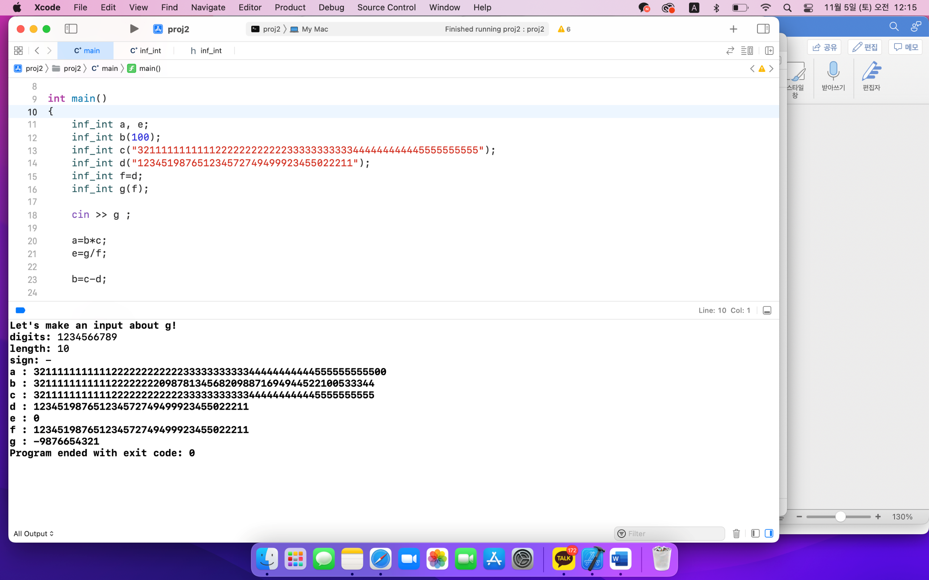

The input is shown above. inf_int a and inf_int e is defined. And there’s inf_int b(100), inf_int c(“with some very big number”) and inf_int d(“also with very big number in the form of character”). Then, we equate inf_int f=d and also makes inf_int g(f). The user makes an input of the information of the g, like digits, length and the sign. We could see the program works very proplerly (below).

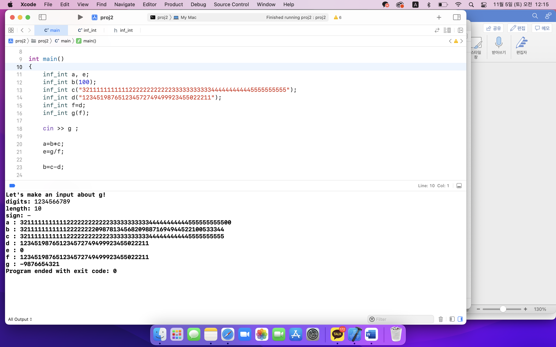

The above test was to check, whether the operation works well. Below one is another test version whether the program derives result properly on prefix and postfix, increment/decrement operator.

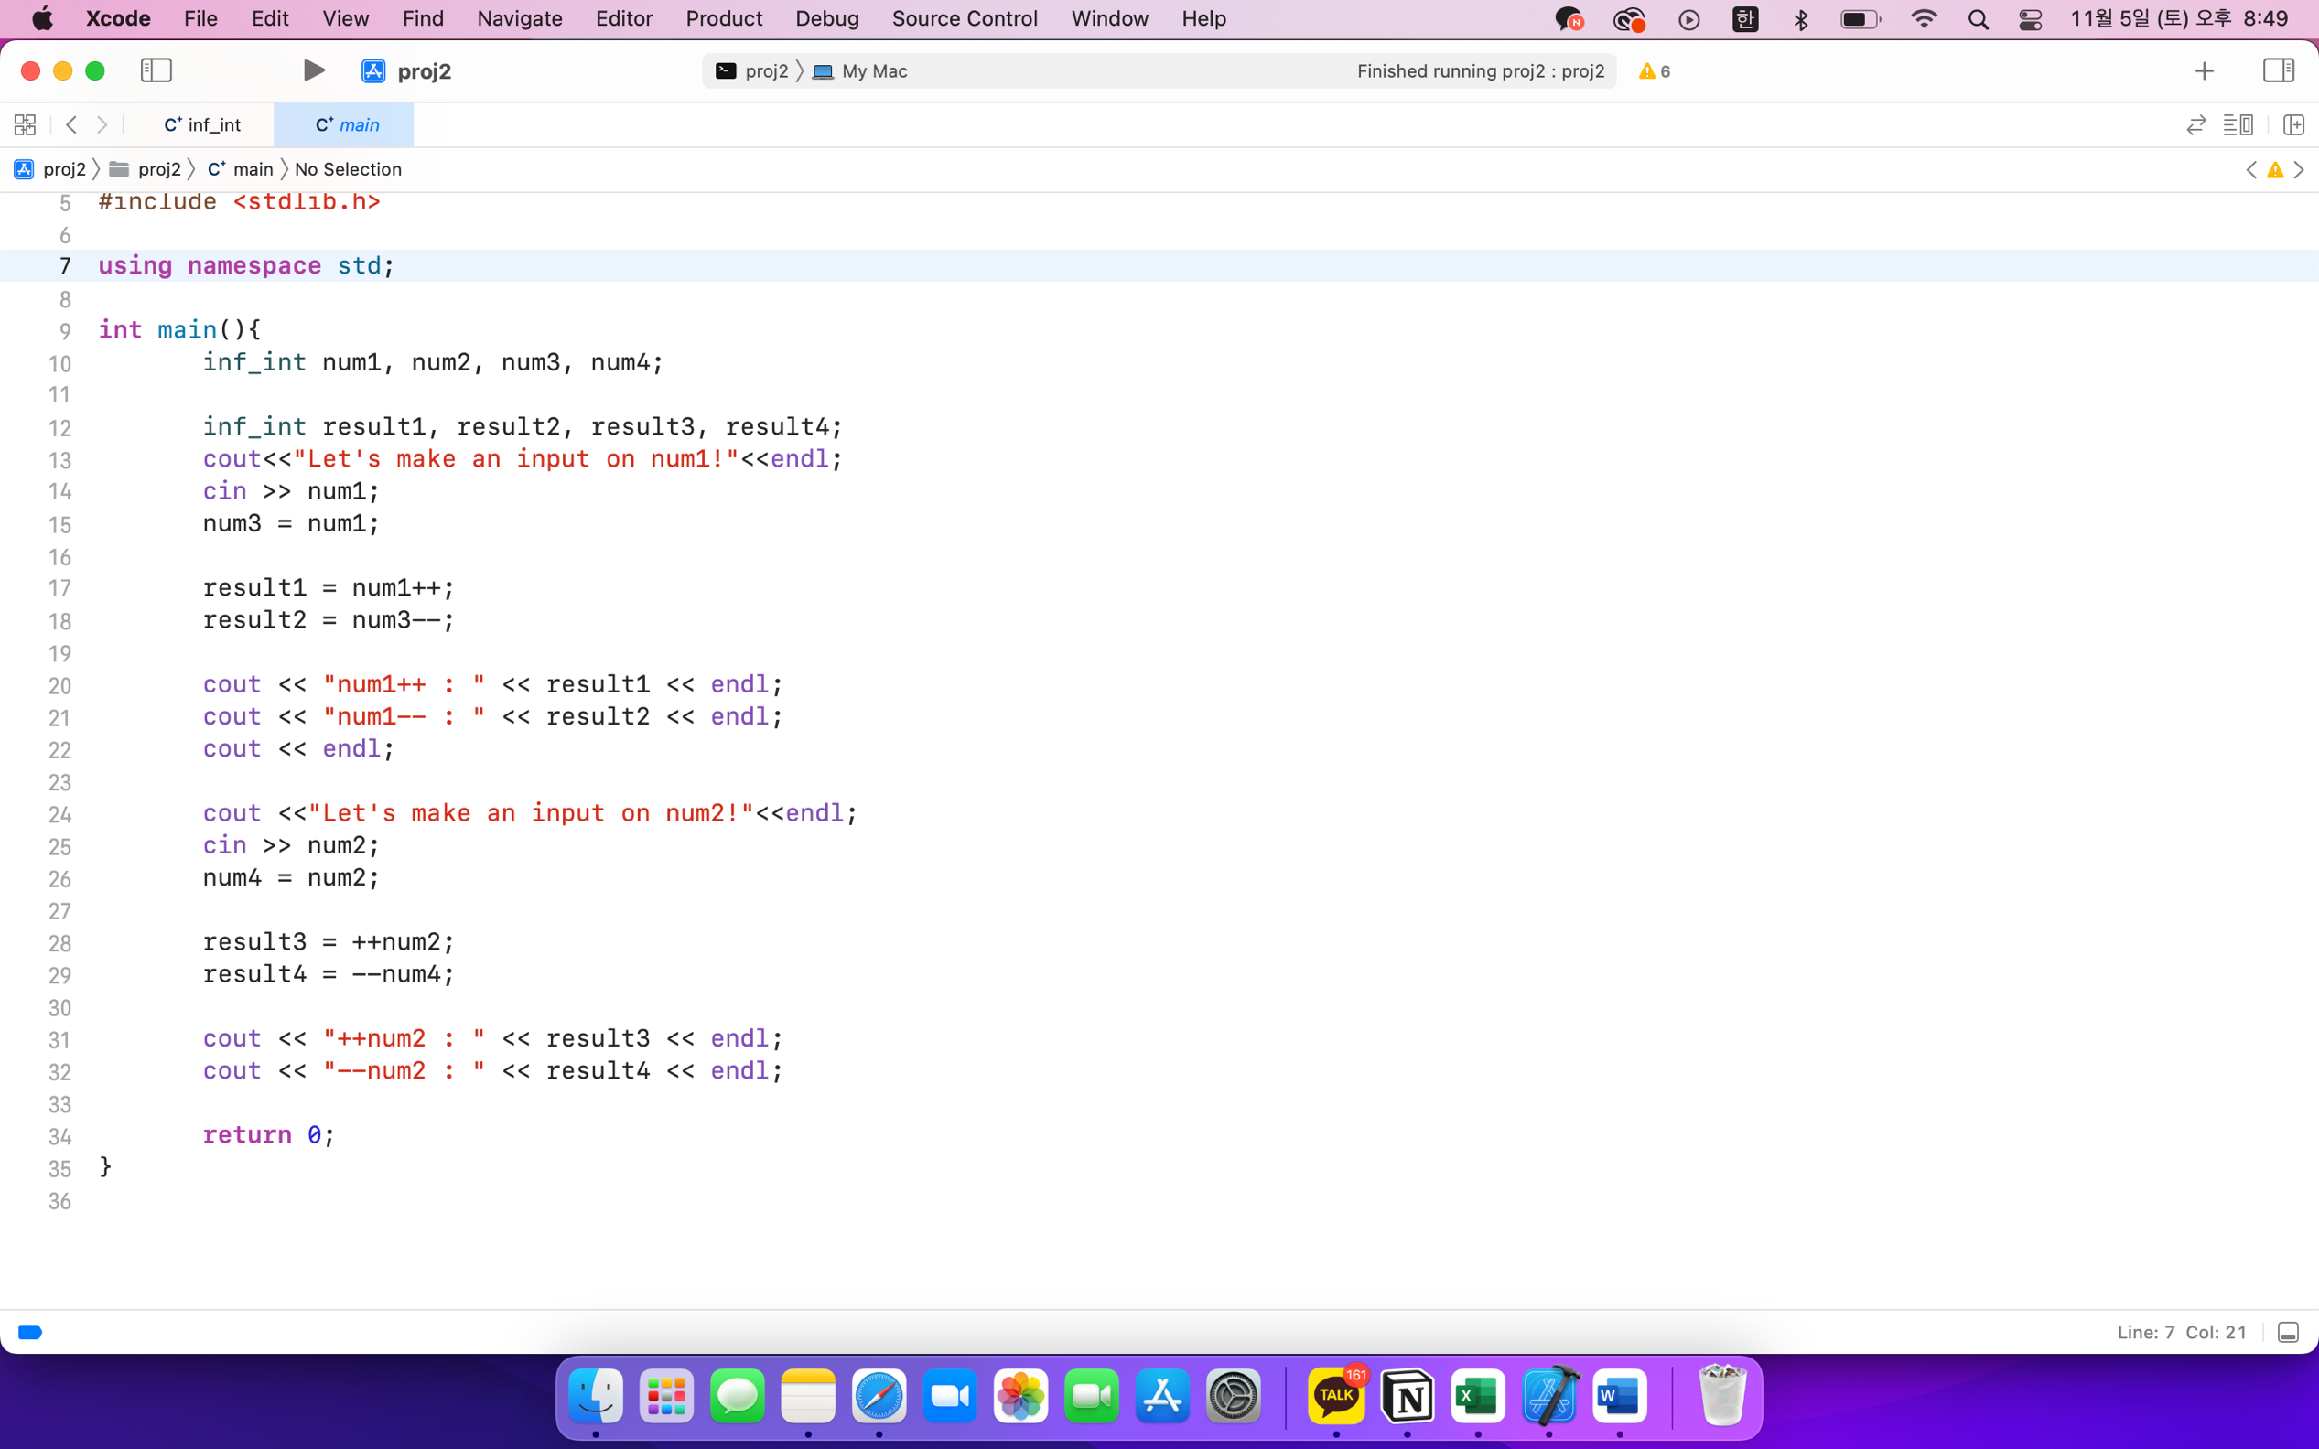

The user could make an input about num1, num2. Then, the program would first show the result of doing postfix increment, postfix decrement. If the user makes an input of another number, the system would show the result of doing prefix increment and decrement operator.

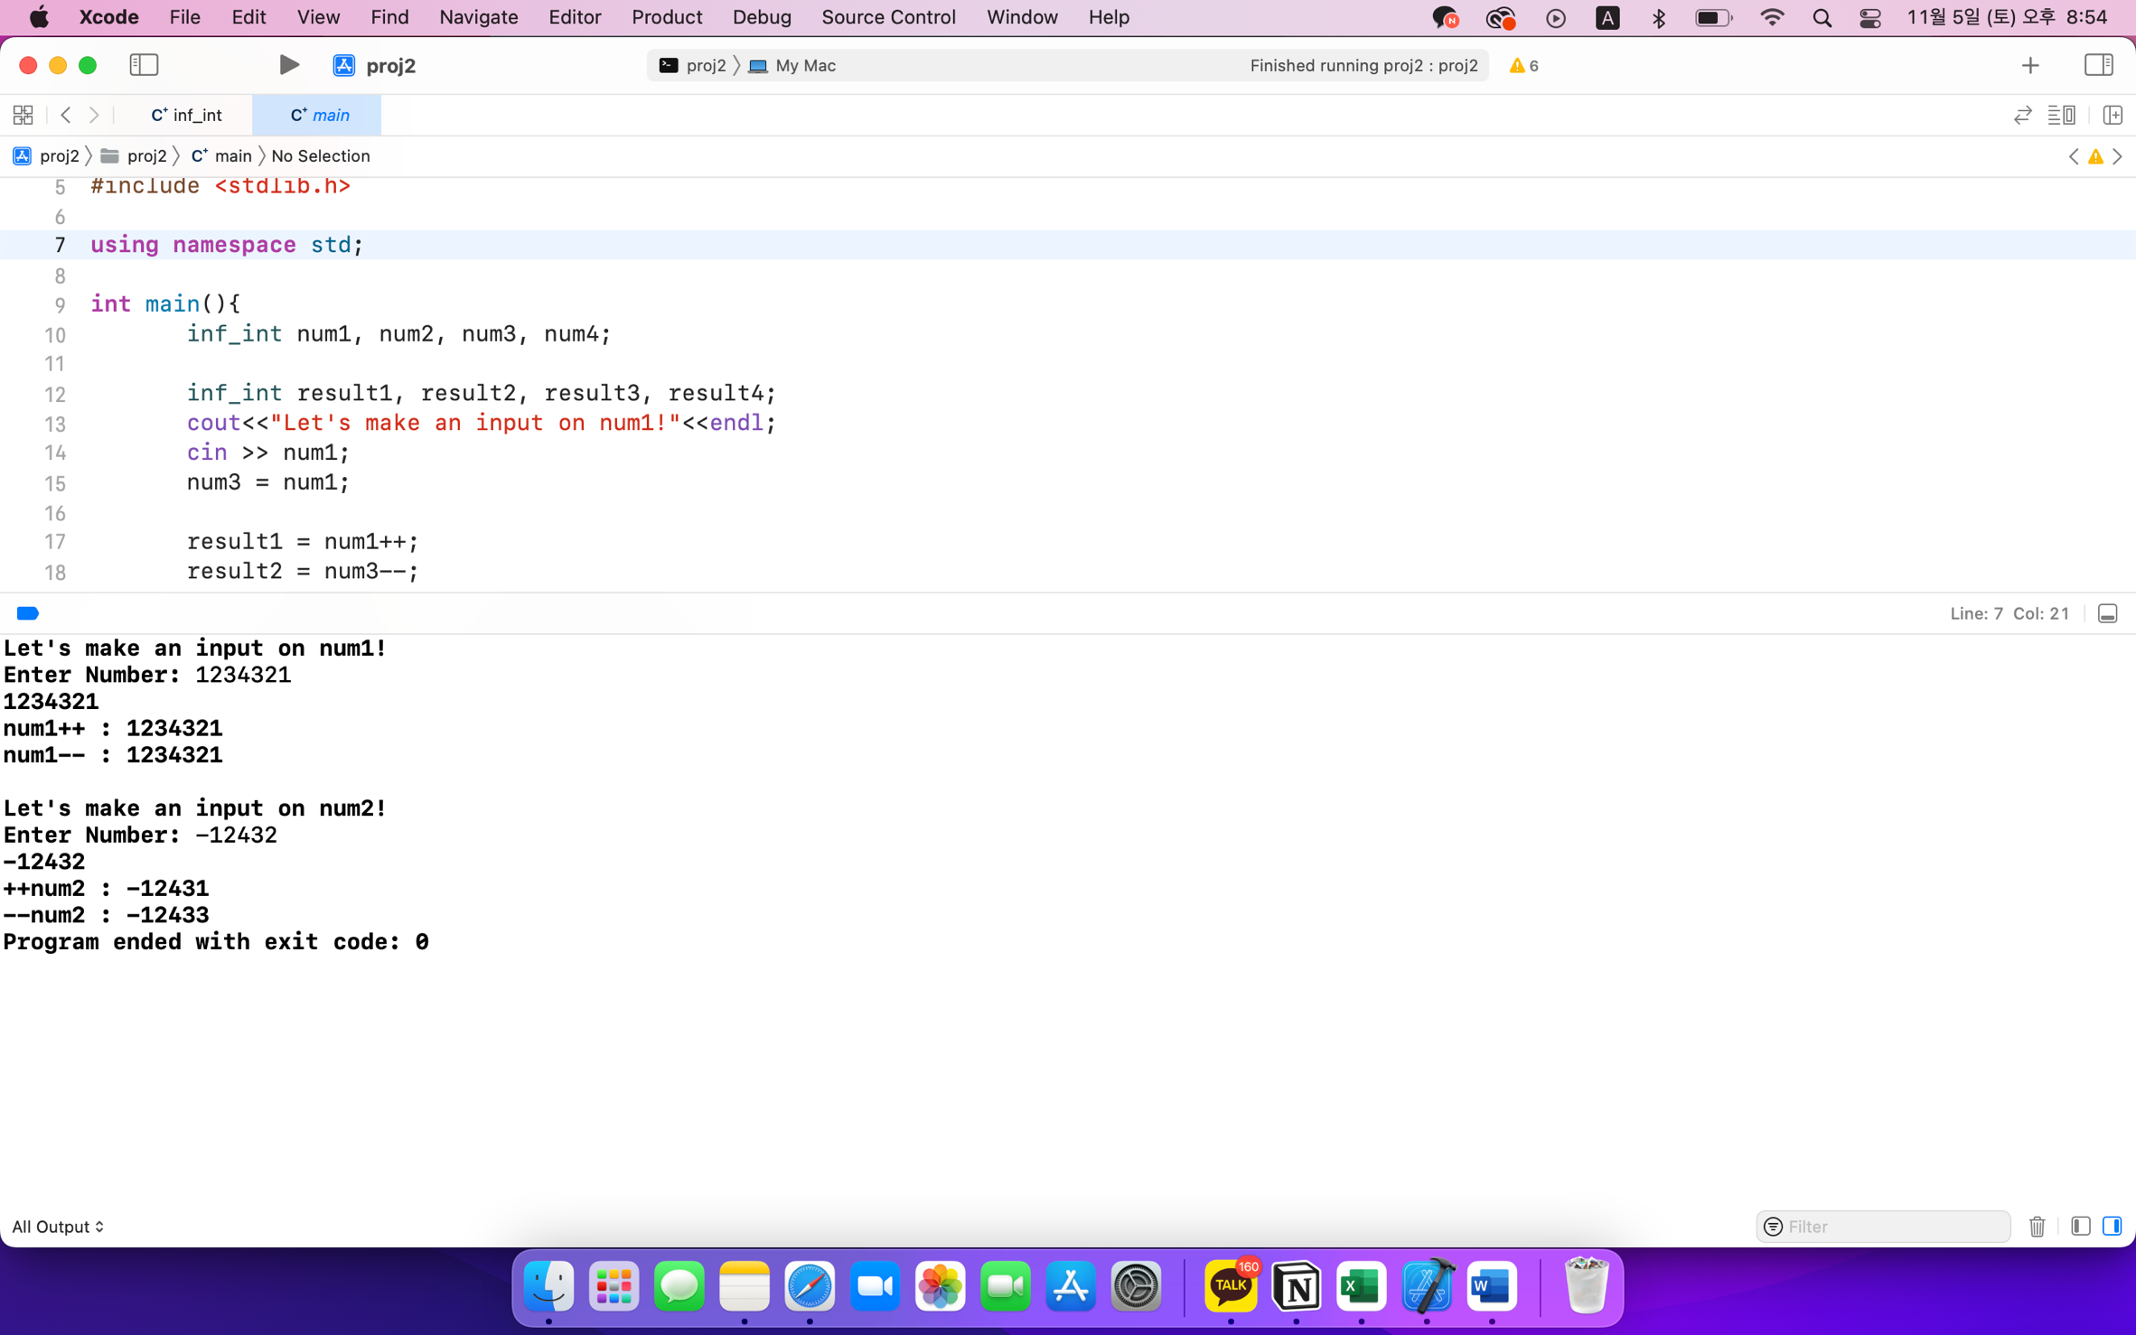

The result is shown above. We could check postfix and prefix, increment/decrement operators work well.

**IV. Review on the project**

**(1) Application of Object Oriented Programming**

The entire software system was made by applying the concepts of object oriented programming. We made the class inf_int for making the object. The object made by the class consists of several information like digits, length and sign. And its function is also combined with its object. This means whenever we create a new object from the class inf_int, it contains all the information and all the functions that are needed for the operations. Then, these newly created objects make the program, which equals to doing the operations for the very large numers.

**(2) Opinion on the Project**

This project provided us a very good opportunity to think about how the basic operations(add, subtract, multiply, divide) work. As these operations are connected, error in one operation could lead to error in another operation. Correlated errors made us feel little difficult, but it made us to do much better in debugging and doing testing. The project also made us feel very proud of overcoming the limits that we face when using the calculator.

**V. Conclusion**

The project was to implement the program that could do operations for very large numbers. To do the operation, we made the class inf_int, which consists of basic information (digits, length, sign). Then, we contained various members and functions for operations.

Doing this project made us to do better on thinking about the various cases of the problem. We hope this project would be a big help to overcome the limitation of basic calculator we use in the daily life.